**Youth in Christ: Our Shared Journey**

A reflection on Journeying in Communion with Youth in Christ

**Sr. Sharon T. Palencia, OND**

CBC PNGSI - Youth Commission Secretary

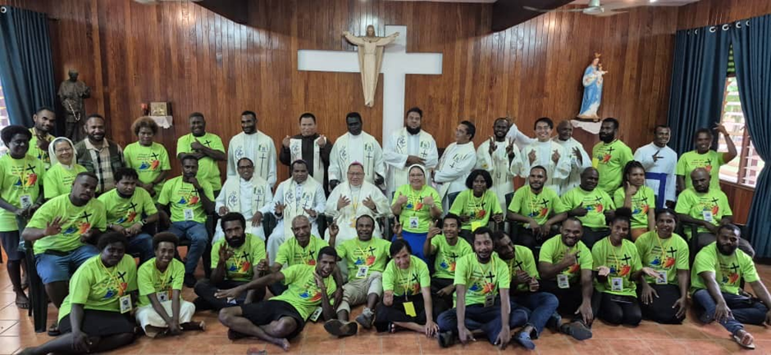

Responding to the call of the Conference Pastoral Plan II (CPP II) and Christus Vivit, the Youth Commission in the Conference of Papua New Guinea and Solomon Islands (CBC PNGSI) is finding its way to live its vision -mission and its goals in journeying together in communion with youth in Christ.

In the Conference Pastoral Plan II (CPP II) 2022-2027, the Catholic Church of PNGSI envisions to be a Church alive in Christ, witnessing the love of God in synodality as salt and light in the world. Its aim is to live a life of communion, participation and mission in families, basic Christian communities, parishes, and dioceses. And will have experienced Jesus Christ through the sacraments, in the scriptures, catechesis and Catholic social teachings. CPP II stipulates that youth receive faith and education formation, and those programs be developed to involve them in parish/diocese communities.

Likewise, inspired by the Holy Father’s Post-Synodal Apostolic Exhortation to the youth “Christus Vivit” in 2018, the Youth Commission initiated the revision of its guidelines to address the signs of the times in ministering to the Catholic youth. The revision of the Framework for Catholic Youth Ministry (FCYM) will be a guiding tool for every Diocesan Catholic Youth Group in Papua New Guinea and the Solomon Islands. Its purpose is to enhance the appropriateness of practice for youth coordinators, improve the quality of youth programs, and set new benchmarks for current activities.

Herewith, the Youth Commission organized and started the Workshop for Youth Animators and Leaders in 2022 (Phase I – for youth profile). Following the completion of Phase I of the workshop, the National Youth Coordinators Workshop 2024 (Phase II) kindled the mindset of the PNGSI Youth Animators and leaders, created the path to discern together in the finalization of the Youth Profile in the spirit of synodality, animated to live out the call of Christus Vivit, enhanced their perspective in ministering the young people as they named the **Catholic Youth Ministry Seven (7) Priorities:**

1. Young people with well-organized Youth Ministry
2. Empowered and self-reliant young people
3. Culturally rooted young people
4. Young people formed and grounded in the Catholic faith
5. Young people accompanied in their vocational discernment
6. Young people as active evangelizers
7. Young people living Christian values.

After identifying the priorities, we envisioned that 10 years from now there will be changes and conversions with the youth and we created a **generative image – “Youth in Christ”.**

The Phase III - Workshop in June 2025 led us to the completion of the FCYM with brighter hopes that the suggested actions and responses for the 7 priorities would be implemented and lived out in the arch/dioceses. The roles and functions of youth ministers and leaders at the diocesan level were identified and updated. The programs and activities were categorized according to age brackets (16-20; 21-25; 26-30) of the youth.

What is it meant by “youth” or "young people"? The term "young people," as defined by the Synod Fathers and in Christus Vivit (2018), is those aged 16 to 30 (single), which include youth (adolescents) and young adults (collegians and above). The youth form a large part of the communities of PNGSI. They are a very significant percentage of the people. Most of them are in the rural areas (around 87%) and come from rural-based families who earn their living through farming, hunting and fishing. Many of the youth move to the cities to study and to look for work. However, a significant proportion of the youth population is not attending school due to financial constraints, lack of access to education, and other challenges. Some are taking on the responsibilities of adults while others are just waiting for their fate.

The youth population in these countries is relatively high and the lack of proper health facilities, educational opportunities, and other basic services produces a strain on youth development. On the contrary, there is an increase in violence, drugs and alcohol abuse, sexual abuse, domestic violence, deterioration of mental and psychological health, etc. The Catholic Church is involved in modifying these issues through its programs and services. It serves as a beacon of hope for the people living on the fringes of society and fills in the gaps where the needs are not met.

Moreover, the Youth Commission is finalizing the revision of the FCYM and is very hopeful for its publication and launching in 2026. While we anticipate the upcoming event, we continue to remain steadfast in our efforts to journey with our young people in the spirit of synodality – communion, participation and mission. We are in close collaboration and partnership with the arch/bishops in CBC PNGSI, diocesan youth animators/coordinators, youth chaplains, youth leaders, and youth parents. Likewise, we link with other youth stakeholders in the government and non-government organizations as well as in the Catholic schools for youth visitation and outreach program.

The financial support of Missio Aachen and PNG Community Development and Religion is indeed a big help in the implementation of the Youth Commission’s outlined programs and activities. We are grateful for the support and teamwork of other Commissions in CBC PNGSI especially the Family and Life for the assistance and partnership, for friends and benefactors for their generosity and support. Truly, the spirit of Synodality is lived and practiced among the Catholic Youth Ministry.

This Jubilee year 2025 inspired us to be really pilgrims of hope. As Pope Francis said, “Christ is Alive. He is our hope, and in a wonderful way he brings youth to the world.” I can personally attest that the young people are full of hope. They are enthusiastic and creative in many ways. They are the Church of today and the future. As PNG turns 50 Years of Independence, it is our hope that our young people will serve as a living witness of the richness of its culture and history, promote moral values and protection of our common home (environment), use social media as a medium of peace and truth, and above all stand for the common good by condemning corruption, criminal acts, violence, and injustices. Similarly, Blessed Peter To Rot will be canonized this year too; it is our prayer that our young people draw inspiration in his life of faith and for the protection of the sanctity of marriage.

**Youth in Christ: Our Shared Journey.** Remember, youth is not a problem to be solved in the community, but a group of individuals – in a particular stage of life that needs to be animated towards holiness. As Catholic youth ministers, let us continue to journey our young people with a pastoral heart – ready to love, listen, and accompany them in their search for truth. May we continue to nurture in the hearts and minds of the youth the truth and proclaim that: God loves you; God saves you and Christ is alive.

Let us always remember that by evangelizing the young, they themselves become agents of evangelization in the world. And so, let us check and change our mindset, contextualize our youth ministry by reading the signs of the times, and set new direction - “being with the young and doing for the young”. Then we can eventually say that “Youth in Christ: Our Shared Journey”.

May the Blessed Mother Mary, a model disciple and model of hope, intercede for us and be our constant inspiration in journeying in communion with youth in Christ. Lastly, Jesus assures, ‘I am with you always until the end of age (Mt. 28:20).